|  |  |  |  |  |
| --- | --- | --- | --- | --- |
|  | INTERNATIONAL TELECOMMUNICATION UNION  TELECOMMUNICATION STANDARDIZATION SECTOR  STUDY PERIOD 2022-2024 | | Focus Group on AI Native Networks | |
| AINN-I-xx | |
| Original: English | |
| Question(s): | | N/A | Virtual, TBD 2024 | |
| **INPUT DOCUMENT** | | | | |
| **Source:** | | *Federal University of Technology, Minna* | | |
| **Title:** | | *Tech Rangers Report on* *ITU WTSA Hackathon 2024 – Using AI to Reduce the 6G Standards Barrier for African Contributors.* | | |
| **Contact:** | | Emmanuel Othniel Eggah | | E-mail: emmanueleggah@gmail.com |
| **Contact:** | | Eniola Aloa | |  |
| **Contact:** | | Frank Chukwubuikem Ebeledike | | E-mail: frankcebeledike@gmail.com |
| **Contact:** | | Aaron Emmanuel Enejo | | E-aiaaronemmanuel054@gmail.com |
| **Contact:** | | Victor Onah Chukwuebuka | | E-mail: onahvictorc@gmail.com |

|  |  |
| --- | --- |
| Abstract: | This document contains the submission report for team name “Tech Rangers” towards ITU WTSA Hackathon 2024 for use case *“Using AI to Reduce the 6G Standards Barrier for African Contributors”.* |

## **Use case introduction: “Using AI to Reduce the 6G Standards Barrier for African Contributors”**

*Bridging the 6G Standards Gap in Africa*:

In developing regions such as Africa, a digital divide persists. Cutting-edge technologies, like 6G, are shaped by global standards that often overlook regional needs. Limited resources, expertise, and networking opportunities hinder regional innovators from contributing to these standards. As a result, communities suffer from poor connectivity, inadequate healthcare, and restricted access to services enhancing sustainable development goals such as education. Local challenges are left unaddressed, and the region's potential remains untapped. The standards gap widens, without considering regional requirements in the global technological conversation. *The Question Remains: How can Africa bridge this gap and leapfrog to take leadership in the 6G technology.*

|  |
| --- |
| Scenario Story:  At the International Telecommunication Union (ITU) headquarters in Geneva, a team of experts had been working on generating a comprehensive knowledge base, adhering to ITU-T Y.3061 standards. Autonomous AI agents are created and deployed in networks by operators, with access to this knowledge base. AI agents identified potential gaps in standards related to network issues for operator X, The Autonomous AI agent flags some such gaps, *Gap-1*, reveals significant call drops in certain locations, requiring optimization of base station parameters via E2 interface. Another gap, *Gap-2*, showed power utilization dependence on time-series data from base stations, also via E2. To make this knowledge base accessible, Utilizing ITU-T Y.3061 standard knowledge base is exposed via chatbot interfaces. Using this interface WINEST chatbot is created to assist students and innovators solving relevant problems.  A brilliant student named Amara in FUT Minna, Nigeria, was determined to contribute to the development of AI-native networks. She was particularly interested in addressing network issues affecting her community. She uses this WINEST chatbot while researching AI-native networks.  So, Amara decided to submit a contribution to ITU regarding AI-native networks and chatted with the WINEST chatbot to generate her contribution. The chatbot leveraged the gaps identified by autonomous AI agents to draft innovative solutions.  The chatbot flagged Gap-1 and Gap-2, generating new interface definitions. So, Amara reviewed these draft contributions, Draft-Contribution-1, with her professor, Dr. Osei, and with ITU experts.  Amara used it to generate sample-code-1 for xApp-based controllers aligned with Draft-Contribution-1. The chatbot produced base line code based on the new interface definitions.  After refining her draft-contribution-1 and sample-code-1, Amara submitted them to ITU. ITU experts reviewed and accepted her draft-contribution-1, complete with sample-code-1.  Amara’s achievement sparked a chain reaction in the African research community. More students and scholars began collaborating with ITU experts, leveraging the WINEST chatbot to address network issues and bridge the 6G standards gap. |

Consider the scene map below:

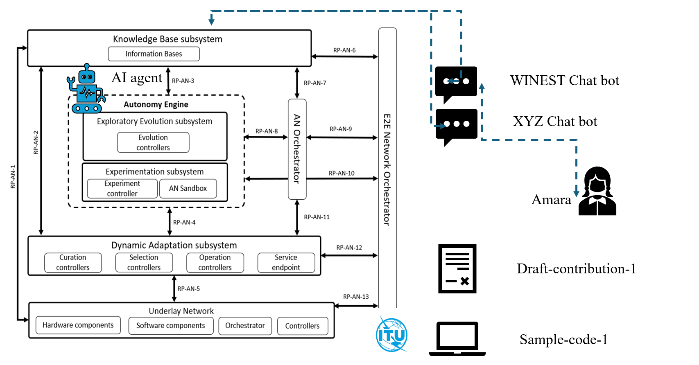

<https://www.itu.int/rec/T-REC-Y.3061-202312-I>

*This is the outline of the USE-CASE*

Step-1: ITU Knowledge base is generated as per ITU-T Y.3061 using ITU standards, data, models, Sandbox and open source. Autonomous AI

agents analyze the ITU Knowledge base. Potential gaps in standards related to network issues are identified by the autonomous AI agents.

(step-1 is very important)

--- Gap-1: Autonomous AI agent analyzes the CDR (Call Detailed Record) and infers that call drops significant in certain locations and hence those

base station parameters should be optimized. This requires new information on base station parameters to be obtained via E2.

--- Gap-2: Autonomous AI agent analyzes the usage pattern and inference that power utilization is dependent on time series data from the

base station. Hence, power optimization depends on new time series data from the base stations via E2.

Step-2: ITU exposes chatbot interfaces for its knowledge base. WINEST chatbot is created to access ITU Knowledge base.

(step-2 is very important)

Step-3: Student in Africa wants to submit a contribution to ITU regarding AI native network's.

Step-4: She chats with the WINEST chatbot for generating contribution.

Step-5: Chatbot uses potential gaps in standards related to network issues identified by the autonomous AI agents for generating

draft contributions.

Draft-Contribution-1: WINEST chatbot flags gap-1 and gap-2. It generates new interface definitions based on gap-1 and gap-2.

Step-6: She reviews the draft contributions with her professor and ITU experts.

Step-7: She generates sample code for xApp based controllers (refer to: ITU-T Y.3061) aligned with the draft contribution using the chatbot.

sample-code-1:WINEST chatbot generates app.py based on new interface definitions in draft-contribution-1.

Step-8: Her contribution (draft-contribution-1) is accepted along with sample code (sample-code-1).

## **use case requirements**

Requirement-1: It is critical to perform NLP parsing on the Raw data.

Requirement-2: It is critical to annotate the data as a step to preparing the data for fine turning/ training

Requirement-3: It is recommended to use validated responses for the fine turning

Requirement-4: The Potential innovator requires the inferred knowledge to generate responses on 6G innovation.

## **PS1: pipeline design**

* AI /ML Concept used is Generative AI to build Chabot
* **In Relation with  ITU-T Y.3061**– for **submission**

**Requirements for this type of application?**

* SRC of data: ITU standard material
* Collector: Cloud (AWS)
* Models: Generative AI
* Policies: Text generation based on prompt
* Distributors: Cloud (AWS)
* Model inference Application (SINK): xApp

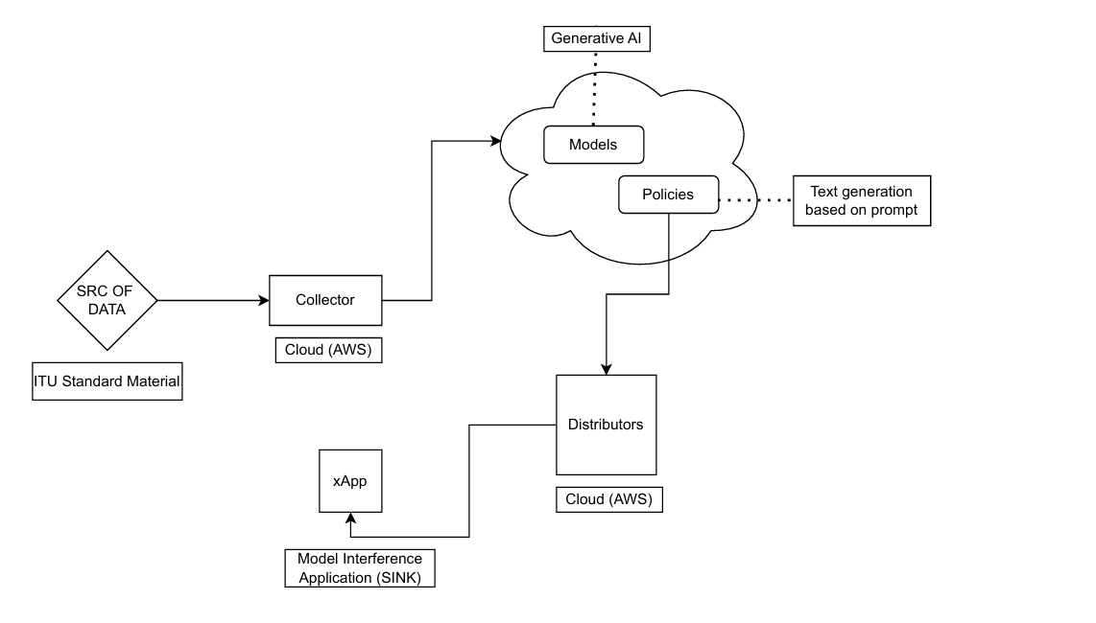

YAML CODE TBD

## **PS2: xApp design**

* Open RAN concept uses TBD

**Role of the xApp:**

The xApp is responsible for processing the data, making resource allocations, and sending feedback on AI-generated contributions based on network gap detection.

**Role of the Sandbox:**

Operators will test different AI/ML strategies for analyzing call drop issues, power utilization data, and standard contributions in the sandbox before final field deployment. This ensures the effectiveness of AI-based solutions proposed for bridging the 6G standards gap.

**xApp Code Design:**

# Send an E2-like request to analyze network data and detect call drops or power optimization gaps

1 conn.send(f"E2-like request for analysis at {datetime.now().strftime('%H:%M:%S')}".encode('utf-8'))

2 # Example: The data collected here pertains to call drop rates (Gap-1) and power usage patterns (Gap-2) in network units.

3 # This section of code retrieves network performance data.

4 data = conn.recv(16384)

5 if data:

6 log_info(self, f"Receiving network data for gap analysis...")

7 while len(data) < required_data_size:

8 data += conn.recv(16384)

# Analyze the network data using AI to identify gaps related to 6G standards

9 current_network_data = data

10 result = run_gap_analysis(self)

11 time.sleep(0.5)

# Take action based on the gap analysis results

12 if result == 'CallDropIssueDetected':

13 log_info(self, "Call drop issue detected, sending control message to optimize base station parameters")

14 conn.send(cmds['OPTIMIZE_BASE_STATION'])

15 elif result == 'PowerUsageIssueDetected':

16 log_info(self, "Power usage optimization required, sending control message for power optimization")

17 conn.send(cmds['OPTIMIZE_POWER_USAGE'])

**Comments:**

1. The xApp is designed to configure resource allocation based on network gaps detected in 6G standards (Gap-1 and Gap-2).
2. The actions taken by the xApp are triggered by AI model inferences, optimizing resources for better network performance.
3. The sandbox provides the environment for experimenting with various resource allocation strategies before actual deployment, ensuring that the system is robust for real-world applications

## **Relation to Standards**

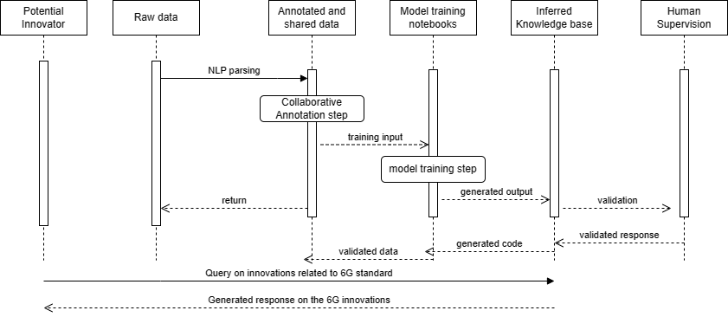

**List of related standards:**

1. **ITU-T Y.3061** – Framework for AI-native networks  
   This standard outlines the requirements for AI-driven networks, including creating knowledge bases for optimizing network performance through AI agents and gap analysis in 6G networks.
2. **ITU-T Y.3172** – Architectural framework for machine learning in future networks including IMT-2020 (5G and beyond)  
   It provides a framework for incorporating machine learning into network architectures, which is closely related to AI-native networks like those in your project.
3. **ITU-T Y.3173** – Framework for evaluating intelligence levels of future networks including IMT-2020  
   This standard is relevant for assessing the level of intelligence in AI-powered networks, providing criteria to evaluate their effectiveness.
4. **ITU-T Y.3100 series** – Standards related to IMT-2020 (5G) and future 6G networks  
   These standards set a foundation for AI integration into 5G and 6G networks, essential for understanding how AI-native systems operate in telecommunications.
5. **ITU-T Y.3500 series** – Cloud computing standards  
   These standards could apply if cloud infrastructures are used to manage and process the data for AI-native networks, essential for scalability and performance in distributed AI systems.
6. **ITU-T Q.3948** – Quality of service (QoS) and Quality of experience (QoE) for AI-driven telecommunications  
   This standard deals with the quality assessments of AI-driven network services, critical for evaluating the performance and impact of AI optimizations on network users.

## **Code submission details**

1. I created the GitHub account
2. I created a repository with public access and commit the file
3. My submission Github repository link is here:

## **Self-Testing results**

TBD